Project Plan

<Project Name>

Student Name: Zhanrui Liao / Student_id: S5290972

Student Name: Chien Huang /Student_id: S5333270

Table of Contents

1.0 Introduction 3

1.1 Problem Background 3

1.2 Scope 3

1.3 Document contents 3

2.0 Work Breakdown Structure 4

3.0 Activity Definition & Estimation & RACI Chart 5

4.0 Gantt Chart 6

# Introduction

## Background

*The aim of this project is to develop a data analysis and visualization tool using a project management methodology called Scrum because of its benefits in terms of being able to respond quickly to change, improving team collaboration and customer satisfaction. This tool will be used to analyse open data from Airbnb in Sydney, a global home rental platform, and Sydney, a popular tourist destination, has a large number of Airbnb listings. Hosts and renters alike face challenges such as setting or finding the right price and knowing which areas are most popular. This tool aims to provide valuable insights to hosts and renters by analysing and visualizing this data.*

## Scope

The scope of this project includes:

Data preprocessing: cleaning and organizing raw Airbnb data.

Data analysis: an in-depth analysis of price, location, and other relevant factors

Data visualization: developing visualization tools to present analysis results in the form of charts and maps.

User interface design: create an intuitive and user-friendly interface for the tool.

The expected outcome is a complete software tool that allows users to select different parameters (e.g., timeframe, region, etc.) for analysis and view clear and accurate visualization results.

Not included in this project:

Mobile application development

Real-time data updates or integration with other external data sources

## Document contents

This document will include the following:

Background and scope definition of the project.

Work Breakdown Structure (WBS) detailing all the different activities and tasks of the project.

Activity Definitions and Estimates, defining clear content and responsibilities for each task or activity and providing time estimates.

Gantt charts, showing the project's timeline and schedule.

*Include some background information about the problem, the scope and what this document will contain.*

# Work Breakdown Structure

*This section should include the work breakdown structure for the whole project. The elements from the WBS should be used to generate your activity definition and those activities should then be scheduled in the Gantt Chart. Remember to consider ALL project activities – anything you do or will need to do should be included in the WBS*

*WBS’s are usually presented as some kind of hierarchical diagram/chart etc. The details what is involved each work unit should be provided in section 3:* ***Activity Definition***

*You do NOT need to do a WBS Dictionary for this project – the activity definition (whilst slightly different) will suffice. The WBS is focussed on SCOPE. The Activity definition is focussed on TIME.*

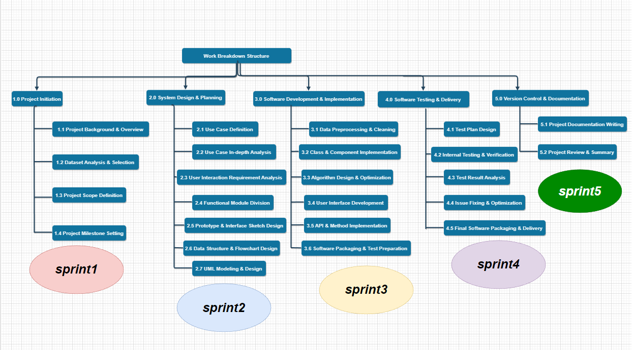

# Activity Definition & Estimation & RACI Chart

*From your WBS, define the activities required for your project. You will revise this document and add more detail for part B as you discover more about the project.*

*Each activity should be clearly identified by a number and should match up to your Gantt chart. You should provide some estimations for the time you think each activity will take. This should make it easy to prepare your Gantt chart.*

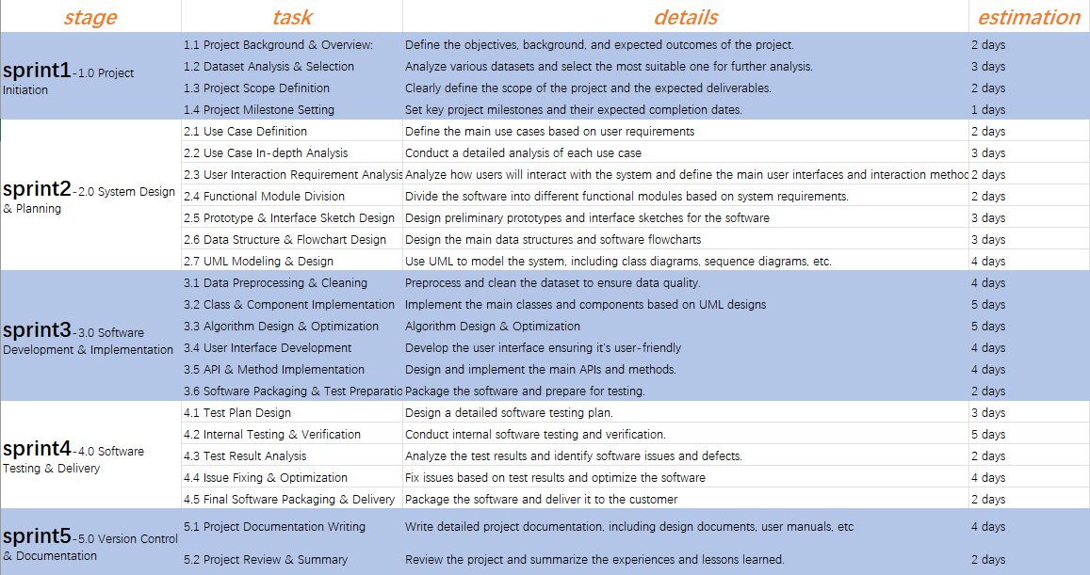

Note: Use Git for version control from the beginning of the project to track all changes.

# Gantt Chart

*This section should contain your Gantt chart. The items in the Gantt chart should match the activity definition from section 3. You should also submit your Gantt chart file separately.*